**Health and History: Skeletons as Sources**

(Full text with images)

**Introduction:**

How do historical conditions influence our health? How does health change history? The After the Plague Project investigates these questions by exploring health in medieval England (400-1500).

The most significant event during this period is the infamous Black Death (the plague epidemic of 1347-51), which killed 30% to 60% of Europe’s population. This project focusses on one medieval archaeological site in Cambridge, and the people who were buried there.

By working through this project, you will find out about a range of skills, strategies and methods which can be applied to your research or to artefacts you might see in museums and galleries. The resource has been written with reference to the A-Level Assessment Objectives to demonstrate how to plan and manage a research project and use a range of different resources.

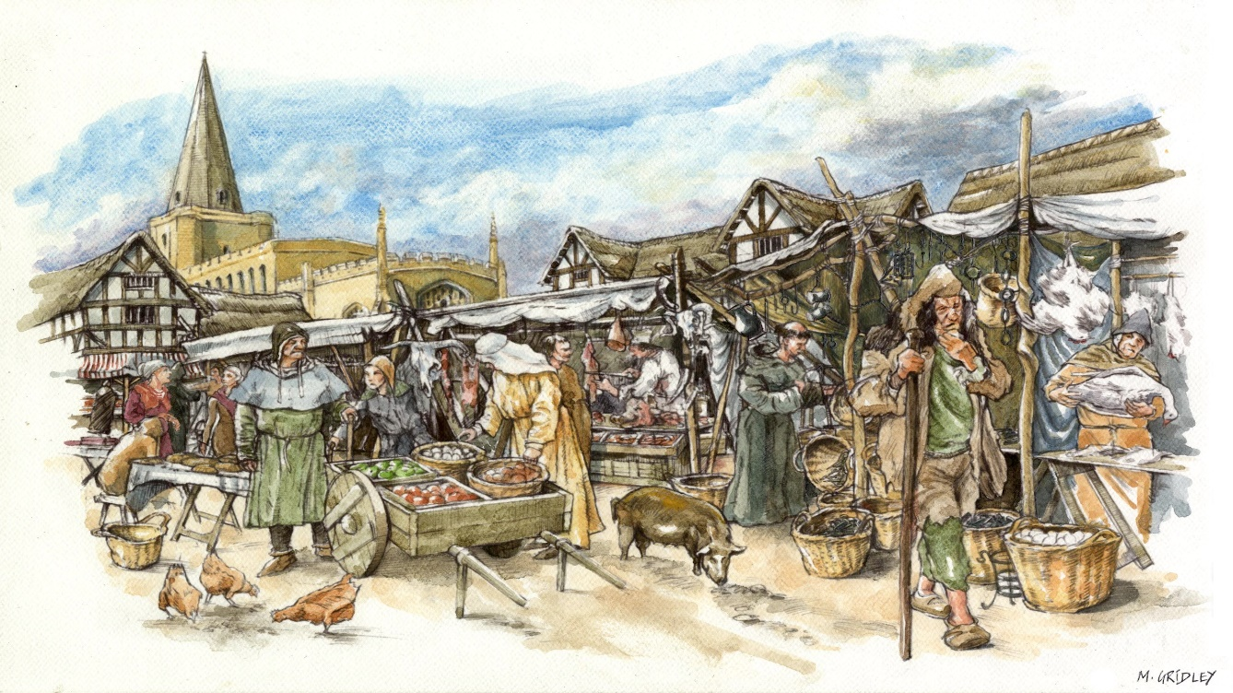This website includes images of human remains.

1. **What were medieval hospitals?**

The medieval hospital has little comparison to a modern hospital: they were religious institutions which also had a role in showing charity. The hospital gave shelter to people rather than giving medical care. We can still find reference to this in words like 'hospitality'.

Hospitals would have provided rest, warmth, protection and food. These things could have made a big difference to a poor person's suffering. Famine and illness were common throughout the medieval period, so finding shelter at a hospital could be the difference between life and death.

Hospitals were used by those most in need, including people who had leprosy, travellers, old people and those who were sick. Wealthier people gave gifts in return for prayers for the giver. This was a way to practise Christian charity.

Medieval hospitals were usually located on routes in and out of town, rather than being in the town's centre. The Hospital of St. John was founded on waste ground at the northern end of Cambridge around 1195. The hospital thrived until the mid 1300s and then slowly declined over many years. Eventually the hospital was disbanded and became part of St. John's College in 1511.

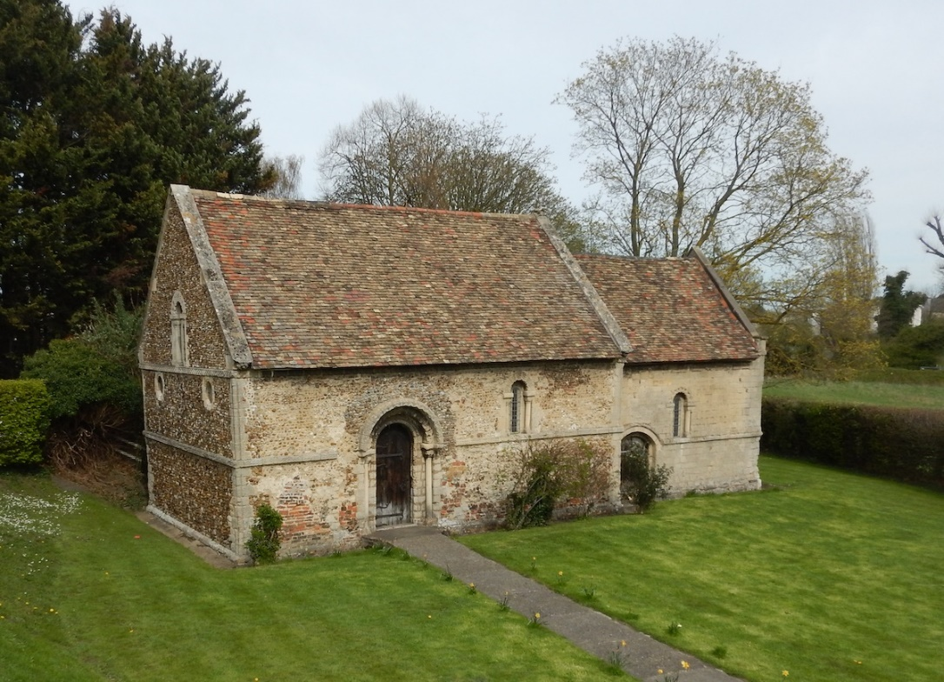The Hospital of St. John probably gave 12 needy people a place to live. These people included poor people and those 'infirm', although the hospital rules stated that pregnant women, wounded people, as well as 'cripples and the insane' were not to be allowed in. Some people had a condition or illness that lasted a long time (chronic illness). Other people the hospital cared for were probably old and couldn't work and support themselves any more, they may not have had family to take care of them. The hospital was a religious establishment and people living there were expected to be Christian, to go to mass and to pray. When the cemetery was excavated both men and women were found to be buried there.

Figure 1. The Chapel of the Leper Hospital at Barnwell, Cambridge. Photograph: Cambridge Archaeological Unit.

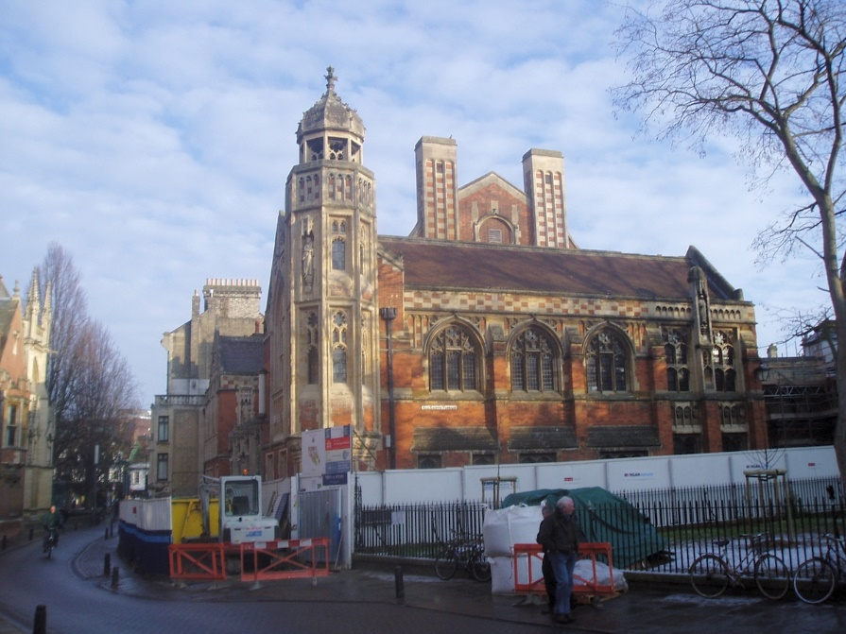

Figure 2. The Old Divinity School of St. John's College, the site of the medieval hospital cemetery. Photograph: Cambridge Archaeological Unit

1. **Excavating the cemetery at St. John's Hospital**

In the early 2000s, St John's College planned to refurbish the Old Divinity School building to improve the facilities. Before they began, the Cambridge Archaeological Unit excavated the area under the building. They found around 400 burials and some artefacts.

Archaeologists think that around 1200-1500 people were buried in the cemetery in total, although the site had already been disturbed by Victorian builders while the Old Divinity School was being built.

On average 4-8 people per year were buried in the cemetery from around 1200 to 1350, but this went down to just to 1-3 burials every year from about 1350 to 1511.

**Who was buried at St. John's Hospital cemetery?**

The hospital could bury members and servants of the hospital, and people who were being looked after there and eventually died. People who gave lots of money to the hospital and senior members of staff were probably buried in the chapel, so we are unlikely to find their remains in this part of cemetery. It is most probable that the skeletons excavated by Cambridge Archaeological Unit were the sick and poor people of medieval Cambridge.

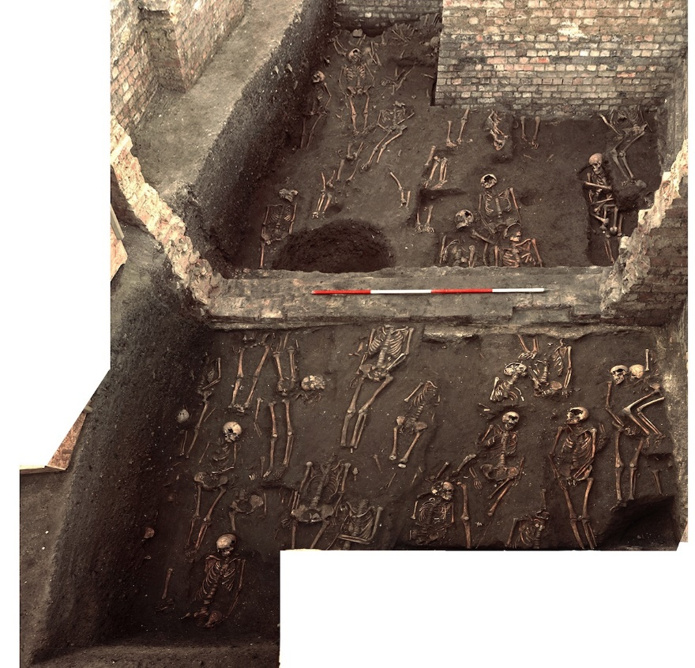

Figure 3. A bird's eye view of the excavation of the cemetery at St. John's Hospital. Photograph: Cambridge Archaeological Unit.

Before you continue with your research, take some time to consider the following questions:

What do you think would happen to the skeletons and artefacts after the excavation?

How should human remains be processed, assessed and reviewed?

What is the most important information to find out from the skeletons?

What further analysis of the site should take place?

What do you think should be recorded and archived?

Do you think all findings should be published?

Do you think it is right for human remains to go on public display?

**3. What information can be retrieved from skeletons?**

A lot of information about a person's life can be obtained through skeletal analysis.

Take 5 minutes to read through the questions below which relate to skeletal analysis. Before revealing the answers, make a note of your own ideas.

**How can you estimate the person's sex?**

Archaeologists usually estimate sex rather than gender as they can only look at the biology of the individual. For most of the medieval period, people were probably gendered the same as their biological sex.

Osteologists (people who study bones) can help to identify whether a skeleton is male, female, or ambiguous. They focus on the pelvis and skull. This method is not completely reliable as there is lots of variation between men and women, and it is almost impossible to identify the sex of children from the skeleton alone. Sex can also be determined from ancient DNA, which can sometimes be extracted from skeletons.

**How can you estimate the person's age?**

This is easier to estimate if the skeleton belonged to someone who was a child or teenager. As you get older, your bones grow and develop significantly. There are also major changes to teeth. Your baby teeth develop and erupt throughout childhood, making way for permanent adult teeth. This process takes place within reasonably set timescales, although some people are late or early developers.

You can also estimate age from bones. As people get older, the growing ends of some bones fuse to short pieces called epiphyses. Although this happens at different ages, most are complete by the age of 30.

As people get older, their skeleton starts to show signs of wear and tear. Teeth wear down and the front of the pelvis or the ends of the ribs can change and be used to give a rough estimate of someone’s age at death.

**How do we know if they suffered any illness or trauma?**

Some diseases leave evidence on the skeleton. As people get older their skeleton can change, showing signs of age. For example, osteoarthritis occurs when cartilage wears away, polishing the bone and sometimes generating new bone growth. 62 skeletons (out of 404 examined) from the cemetery of the Hospital of St. John had signs of osteoarthritis. Some of the skeletons showed evidence of lesions on the spine: these people may have suffered from tuberculosis (TB), a serious and often fatal infectious disease. Most people in medieval Cambridge would have been exposed to TB at some point in their life. People who had it would have had problems breathing, they would cough, sometimes coughing up blood, and they might have had chest pain.

Broken bones can also be identified, as can evidence of any healing that might have taken place. This can give archaeologists an idea of whether a person survived a fracture. 20 of the skeletons examined from the cemetery of the Hospital of St John had at least one fracture, most of which had healed. The majority of these injuries were compression fractures in the spine, which can happen ifthey have osteoporosis or when people fall and land on their feet or bottom.

**How do we know what food they ate?**

Archaeologists can use various sources to determine the diet of people in the past. Plant or pollen remains might indicate what food is growing in the area where people live. Teeth might be worn down, for example because people were accidentally chewing on grit which made its way into food when wheat was ground into flour. Tooth cavities might show an increase in sweet or sugary foods.

It is possible to find out the diet of an individual by analysing two elements in their skeleton. The proportions of carbon and nitrogen isotopes can indicate what that person had been eating. This can tell archaeologists the types of plants people were eating in the past and also whether they were consuming animal products, fish or shellfish.

Famine and starvation happened throughout the medieval period. Sometimes this can be seen in human remains as well. Enamel hypoplasias are marks on teeth, seen as grooves, lines or little pits. These are all signs of teeth not developing properly during a person's childhood, perhaps through poor diet or ill health.

**How can the study of skeletons tell us more about life in medieval Cambridge?**

By putting together the evidence from individual skeletons and the cemetery as a whole, we can start to build up a picture of life in medieval Cambridge. Importantly, the people buried in the cemetery were the poor people of the city: the people who are often missing from written sources of the period. The After the Plague project also looked at other cemeteries from Cambridge. This approach, looking at the whole city, should help us to get a better idea about people’s lives in the past. We can observe how common particular illnesses were, we can track disease across groups, or see how genetically similar people in medieval Cambridge were to each other. By bringing together lots of different types of information we can understand the topic much better than by focussing on one method of analysis.

**4. Who were the people buried at St. John's Hospital cemetery?**

Scientific study allowed experts to find out more about the individuals who were buried in the cemetery.

Find out more by clicking through the series of questions below.

How were people buried in the cemetery of St. John's Hospital?

By looking at the size and shape of the graves, archaeologists thought that most of the people buried there had not been put in a coffin. No archaeological evidence for coffins was found, but it is likely that the bodies had been wrapped in a shroud (a large piece of fabric) before they were put in the ground.

**What were they buried with?**

Medieval Christian burials usually did not include many objects in the grave with the dead person. Although about 400 skeletons were excavated at St. John's Hospital, only a few had objects with them. These may have been deliberately put with the bodies, but they might also have been left from earlier use of the site, or were even rubbish. There were only two items which the archaeologists could definitely conclude were grave goods and a third which was possibly from a grave.

The possible grave good was a cross-shaped pendant made of copper alloy metal. This was found with a small group of bones that had been wrapped in cloth. The cloth had been tied with a cord, and the pendant was discovered with that cord.

The two definite grave-goods were a metal brooch and a jet crucifix. The brooch was also made of copper alloy, and was found with the skeleton of a woman between the ages of 27 and 35 who was buried in the 15th century (1400s).

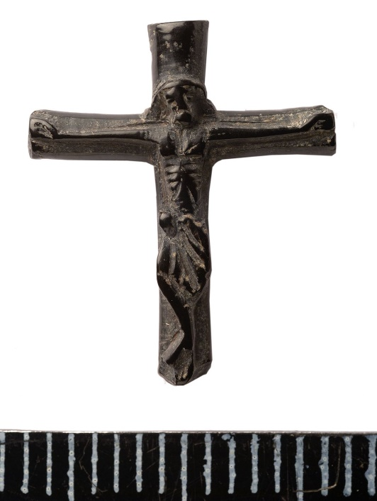

Figure 4. A jet crucifix, discovered during site excavations. Photograph: Cambridge Archaeological Unit

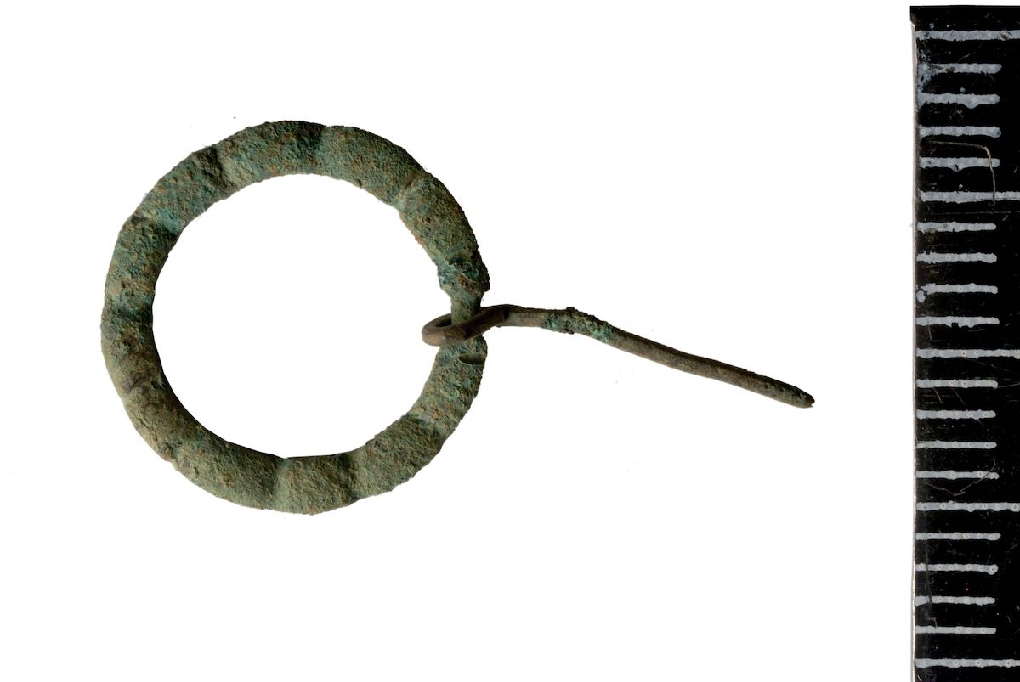

Figure 5. The brooch discovered during the excavation. Photograph: Cambridge Archaeological Unit.

The crucifix was made from Whitby jet and was found buried with a man. It is slightly broken but has been worn smooth, perhaps from being handled. Jet is a gemstone, formed over millions of years from fossilised wood. In the medieval period jet was ground to a powder to use as a tooth cleaner. Rubbing it against wool can make jet develop static charge, enough to pick up a light object. In the medieval period it was commonly thought of as a magical material and was sometimes used as a charm to keep sickness and evil influences away. This piece of jet had been carved into a religious symbol.

**What sort of people were they?**

Documents tell us that the Hospital would not admit particular groups of people, among them pregnant women, people who had leprosy, people with wounds or who were crippled. The people that were buried in the hospital cemetery were probably mostly poor.

Later in the Hospital’s lifetime, they accepted more people called ‘corrodians’. These were basically pensioners: older people who paid to stay in the hospital until they died.

There are very few documentary sources that archaeologists can read to understand who these individuals were. Records from the hospital no longer exist. The only way to find out about many of these people is by using archaeological techniques.

**How can we find out more about them?**

By comparing the archaeological evidence and written records of the time, we can begin to see how the average person may have lived, how they were treated when they were ill, and how they were looked after when they died (burial rites).

Medieval hospitals, like St. John's, did care for people, but in a spiritual sense rather than medical.

**Can we create a biography of individual skeletons?**

To write a biography, usually historians consult written documents: letter, wills, tax records. For these skeletons, the After the Plague project built a picture of that person’s life through their bones: an osteobiography (osteo- means relating to bones). Here we will show how the project put together one osteobiography.

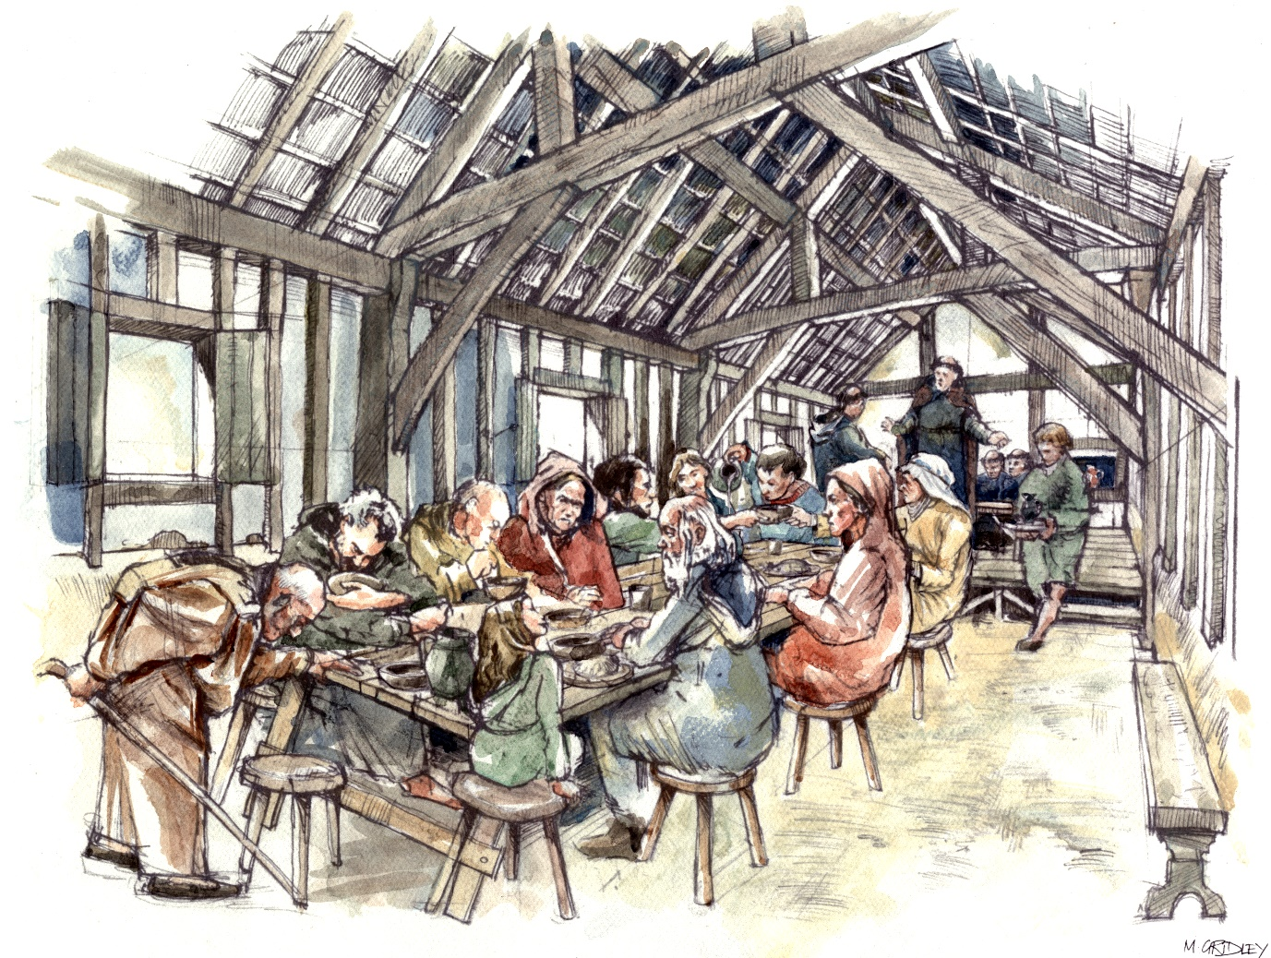

Figure 6. An artist's impression of the Hospital of St. John. Image: Mark Gridley.

**5. Investigating a skeleton: A case study from St. John's Hospital cemetery**

**What do we know and how do we know it?**

This skeleton was found buried face down. He is male; using radiocarbon dating it was determined that he lived in the 13th century (1200s). He was over 45 years old when he died.

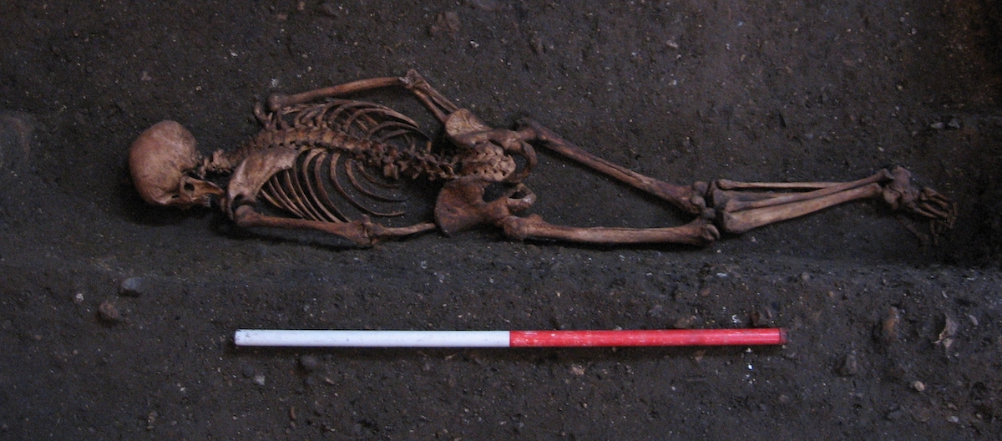

Figure 7. The skeleton in situ, discovered face down. Photograph: Cambridge Archaeological Unit.

By using different investigation techniques, scientists could begin to understand more about this person's life and possible ways they could have died. To find out more click through the series of questions below.

**What can skeletal analysis tell us about his childhood?**

Like a lot of children in the medieval period, there were a couple of times that his growth was interrupted - probably between birth up until he was 6 years old. This could have been due to illness, or not having enough to eat, but he had been strong enough to recover. Unlike half the population born at the same time as him, he survived his childhood. He grew up to be a tall man, one of tallest in whole cemetery (177.5cm). This was above average height for the time.

**How can skeletal analysis tell us where he was from?**

By studying his DNA, we discovered that his ancestors were probably from England. Analysis of his DNA shows that he is not closely related to anyone else buried in the cemetery.

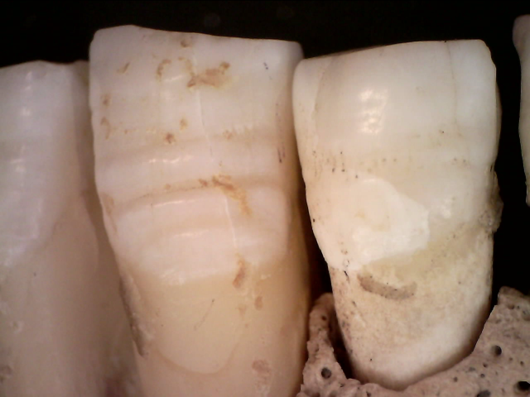

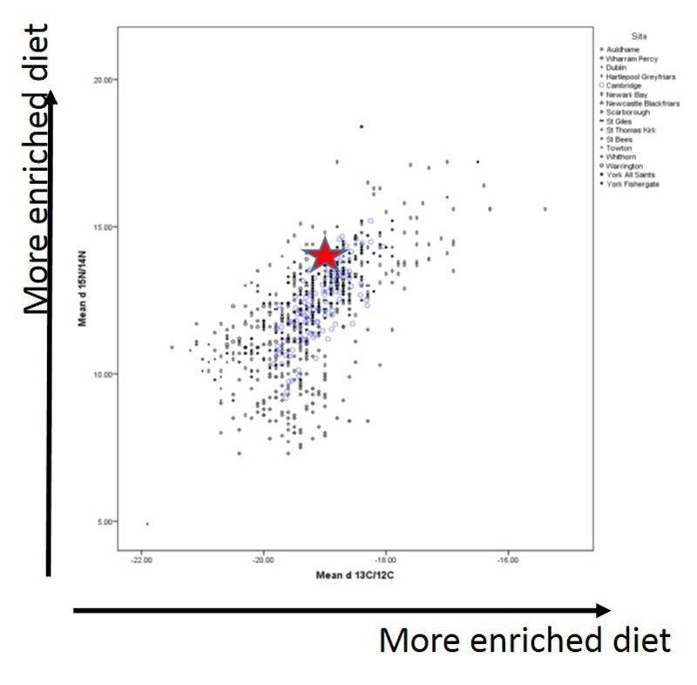Figure 9. Growth interruptions show as ridges in the root of his tooth.

Figure 8. A graph showing that this skeleton (red star) had a richer diet than other people buried in the cemetery. Image: After the Plague

**Can skeletal analysis tell us about the food he ate?**

By looking at his bone chemistry, we can tell that his diet contained quite a few animal products, possibly fish. He would also have eaten an assortment of vegetables and grains, like most people in medieval Cambridge.

It is likely that he wasn’t in the hospital for a long time. Everyone in the hospital would have eaten the same diet and this probably didn’t include much meat.

Does this mean that he had a bit more money?

Was his job good enough for him to support himself (and his family, if he had any)?

**Can skeletal analysis identify any illness or trauma?**

His teeth were in quite bad condition, although would not have been uncommon at the time. He had cavities so would have known the pain of toothache, he also had a tooth abscess.

At some point in his life he had broken a rib and damaged the back of his skull. Both of these injuries had healed before he died.

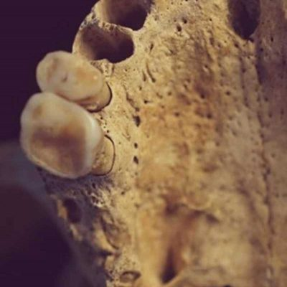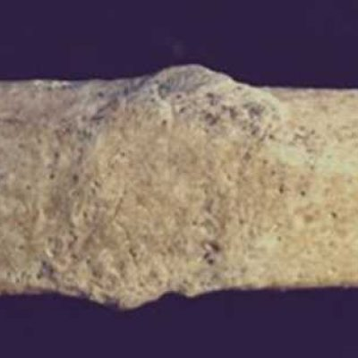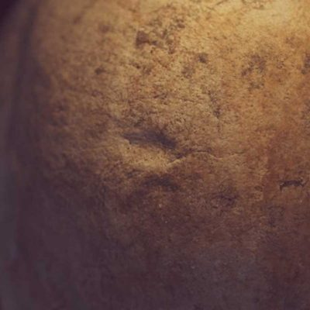

**Can skeletal analysis tell us what sort of job he had?**

He had a robust skeleton with strong muscles, showing he was physically active. He had a lot of lesions (areas of damage) on his spine, these may have occurred because his life involved a lot of lifting. It is highly likely that he did a repetitive activity which caused changes to his toes and feet.

Below is an artist's impression of how he may have looked. This is based on the analysis from the studies listed above.

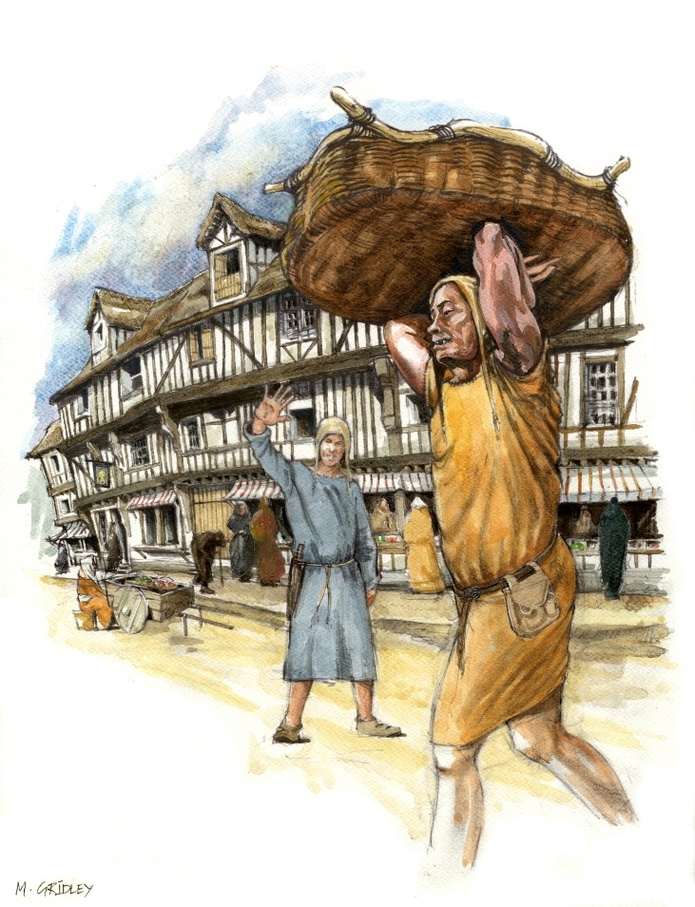

Figure 10. An artist's impression of the medieval man, based on skeletal and site analysis. Image: Mark Gridley.

What sort of job can you imagine him doing?

**Can this analysis determine how the man died?**

We cannot say how he died. Most causes of death leave no trace on bone. He may have had an illness, and with no family to care for him, perhaps he went to the hospital instead. It is also possible that he had worked at or had a link to the hospital and so got buried in its cemetery. It is unlikely that he was a monk or a scholar. What we do know is he was buried in a cemetery for poorer people.

Experts then find themselves asking the following questions:

Why was he buried face down?

Was it a hasty burial?

Or was he buried this way on purpose?

Was his position in the grave accidental?

Unfortunately not all questions can be answered, and the circumstances surrounding his death may never be known.

Further study of the skeleton allowed forensic experts to create a reconstruction of the skeleton's face. Below are some forensic reconstructions carried out by experts at the University of Dundee.

What differences do you see between the faces?

Do these reconstructions change the way you think about him?

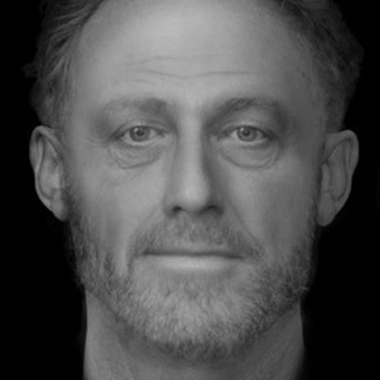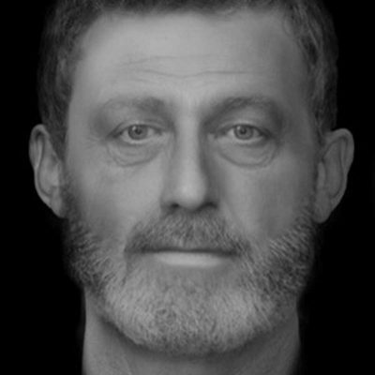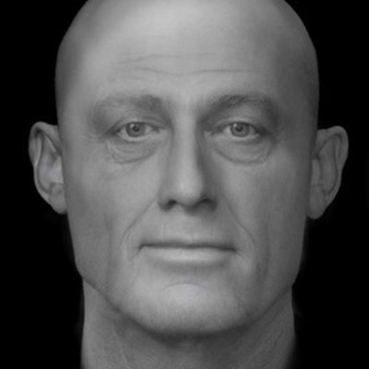

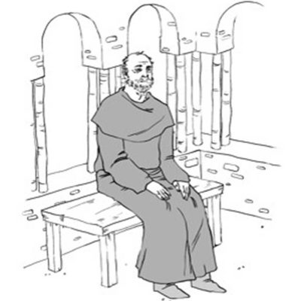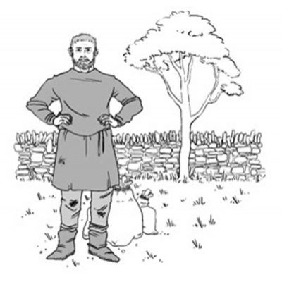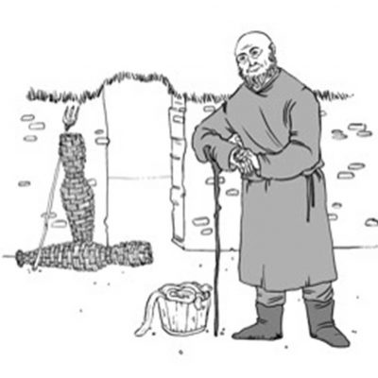

**6. Project summary and further reading**

In addition to this resource more information about the project can be found on the official [website](http://www.aftertheplague.com/).